UNCOVERING TRENDS IN
NIGERIA'S SALES DATA
A Comprehensive Power BI & Python Analytics Report

1.Performing measures in Power Query

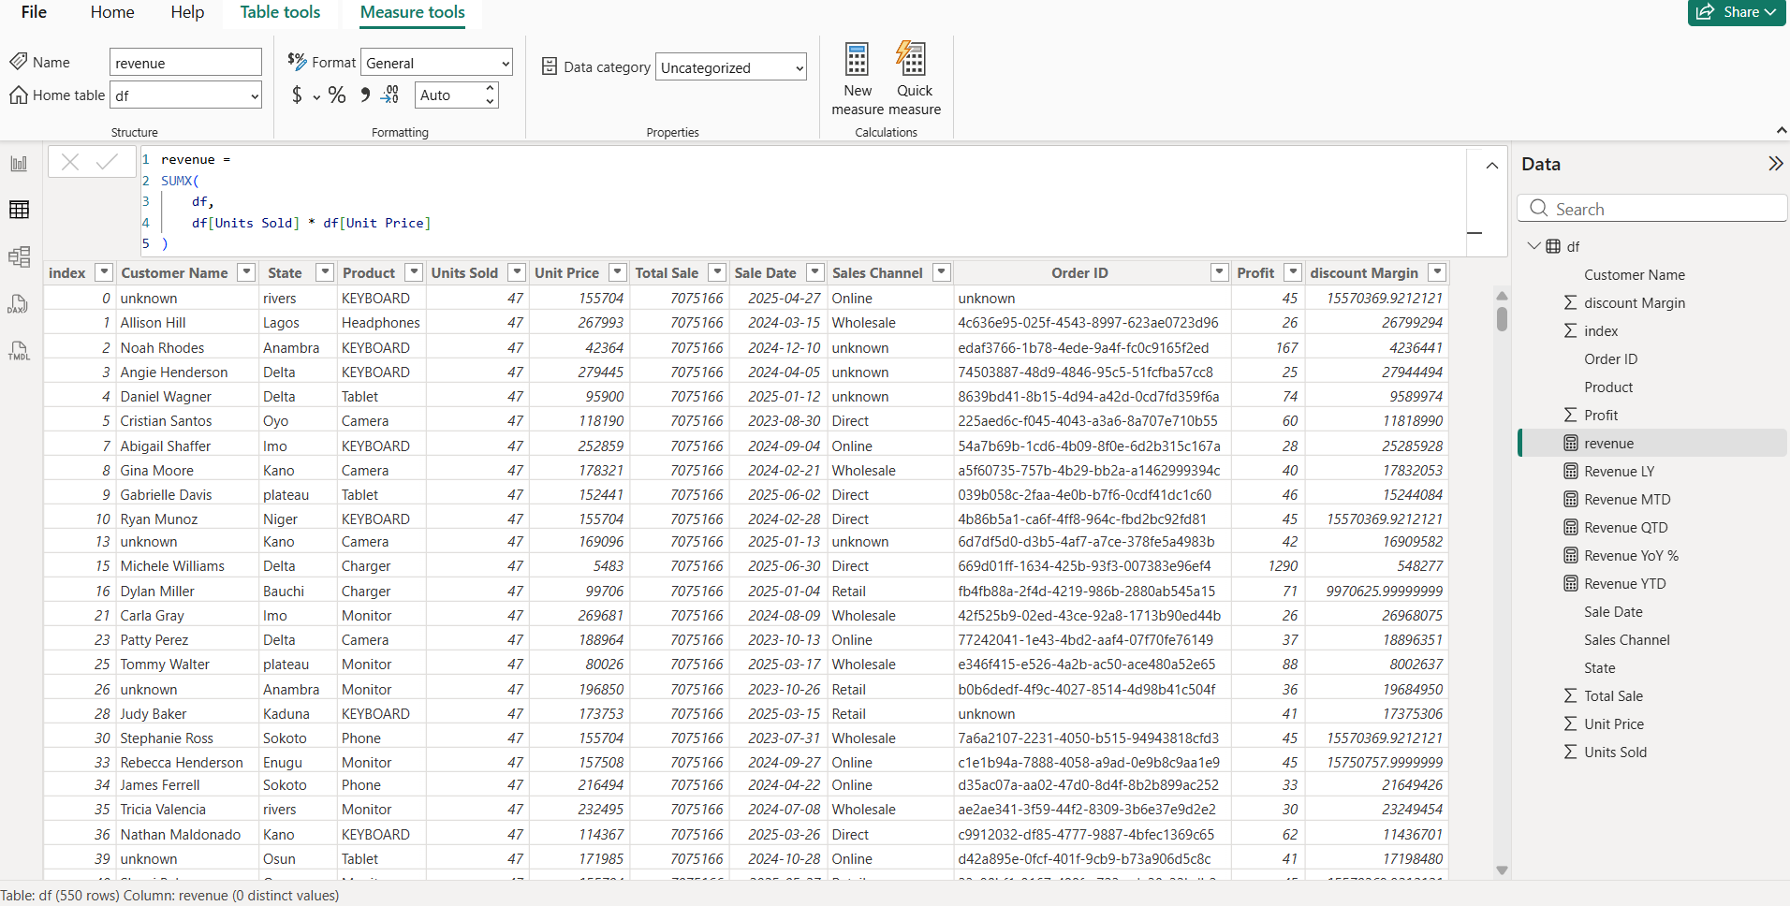
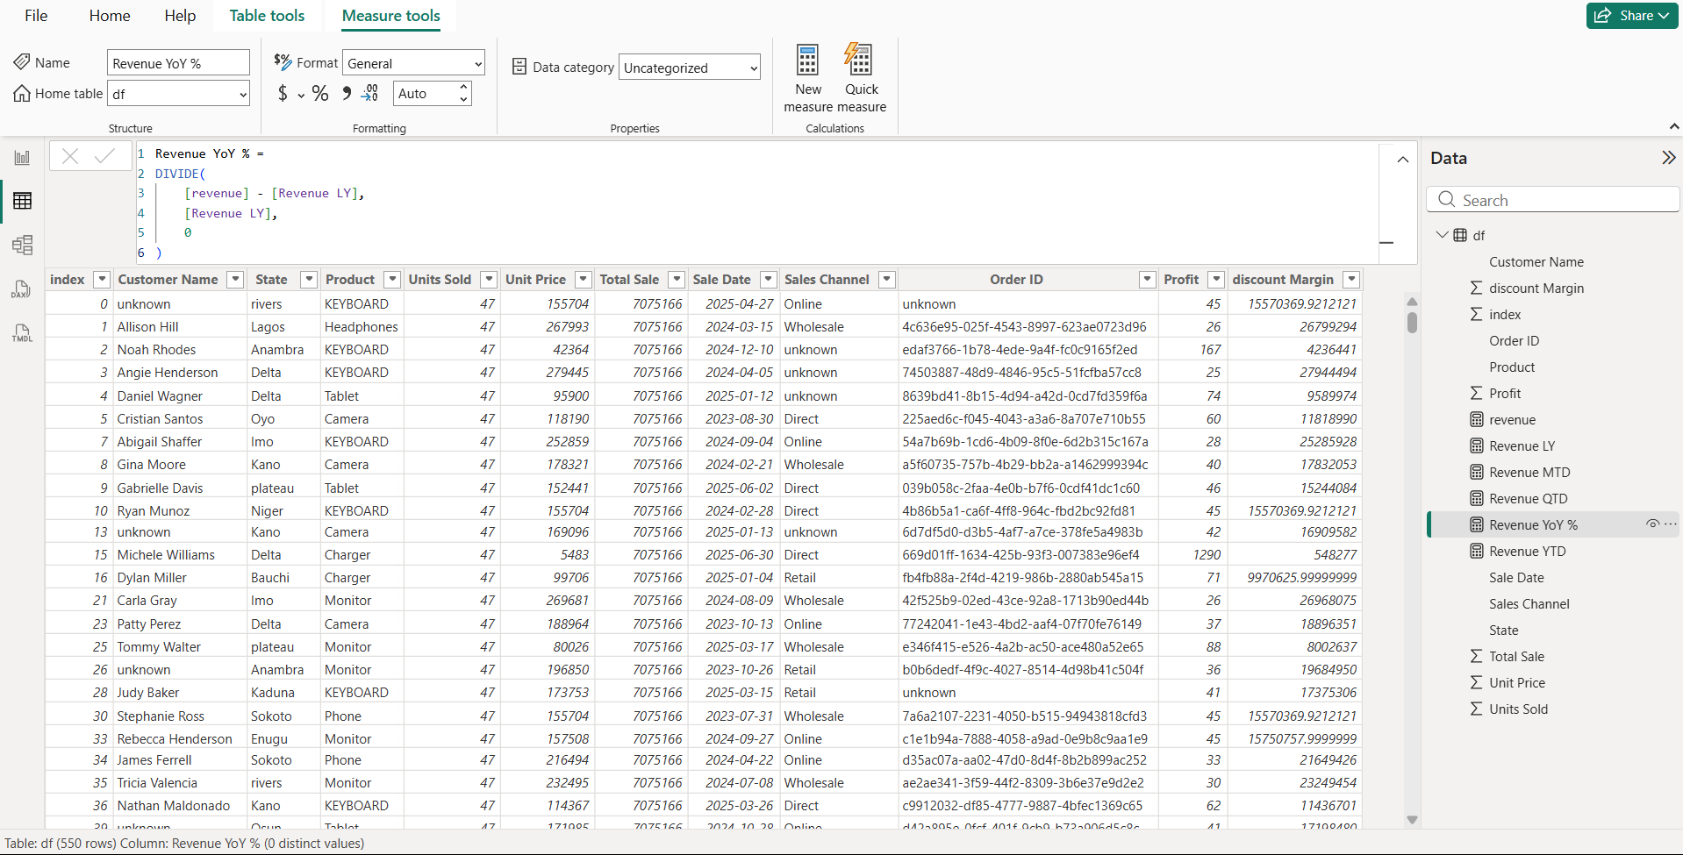

1. Dashboard Overview: Power BI + Python Integration

This report presents an end-to-end sales analytics solution for Nigeria using Power BI connected with Python. The dashboard consolidates multiple data sources into a single, interactive visual environment, enabling stakeholders to make informed decisions quickly.

1.1 Connecting Python to Power BI
Power BI's Python scripting feature (available under the Transform Data > Run Python Script option) allows analysts to leverage the full power of Python's data science ecosystem directly within Power BI. The integration workflow is as follows:

- Install Python (3.x) and configure the path in Power BI Desktop under File > Options > Python Scripting.
- Use pandas for data wrangling, numpy for numerical computations, and matplotlib/seaborn for advanced visualizations.
- Import cleaned datasets using pd.read_csv() or connect directly to SQL/Excel sources.
- Apply transformations (groupby, pivot_table, resample) before loading data into Power BI's data model.
- Use the Python Visual in Power BI to render custom charts such as heatmaps, scatter matrices, and time-series decompositions that are not natively available in Power BI.

1.2 Chart Alignment & Dashboard Layout
All charts in the dashboard are aligned using Power BI's Format > Align and Distribute tools, ensuring a consistent, professional layout. The dashboard is structured into three visual layers:

- Top Row (KPI Cards): Total Revenue, Total Units Sold, Average Order Value, Top-Performing Region — providing an at-a-glance summary.
- Middle Row (Trend & Comparison Charts): Monthly Revenue Line Chart, Regional Sales Bar Chart, Product Category Pie Chart — enabling trend identification and comparative analysis.
- Bottom Row (Deep-Dive Visuals): Python-generated heatmap (correlation matrix), scatter plot (sales vs. profit margin), and a decomposed time-series forecast chart.

Slicers for Region, Product Category, and Time Period are aligned on the left panel, allowing users to filter all visuals simultaneously with a single click.
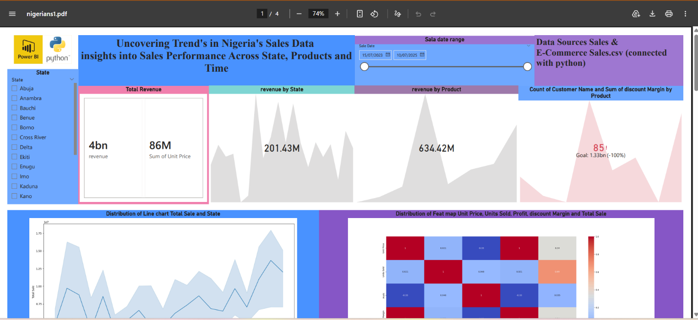
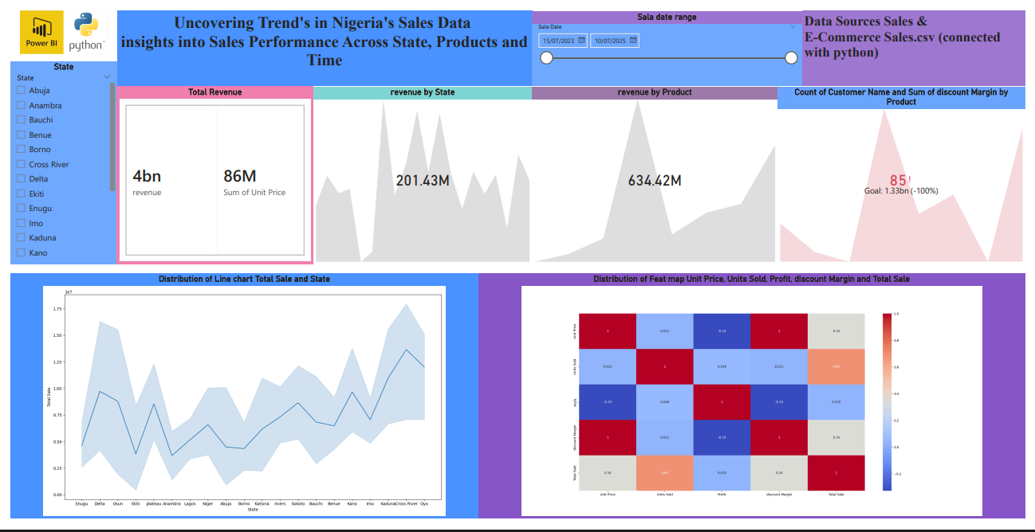
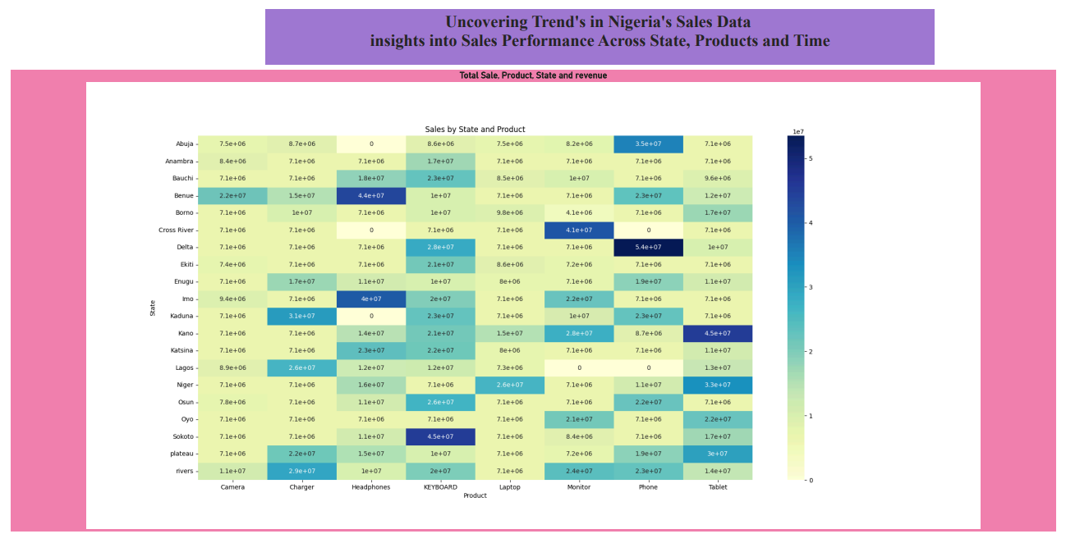
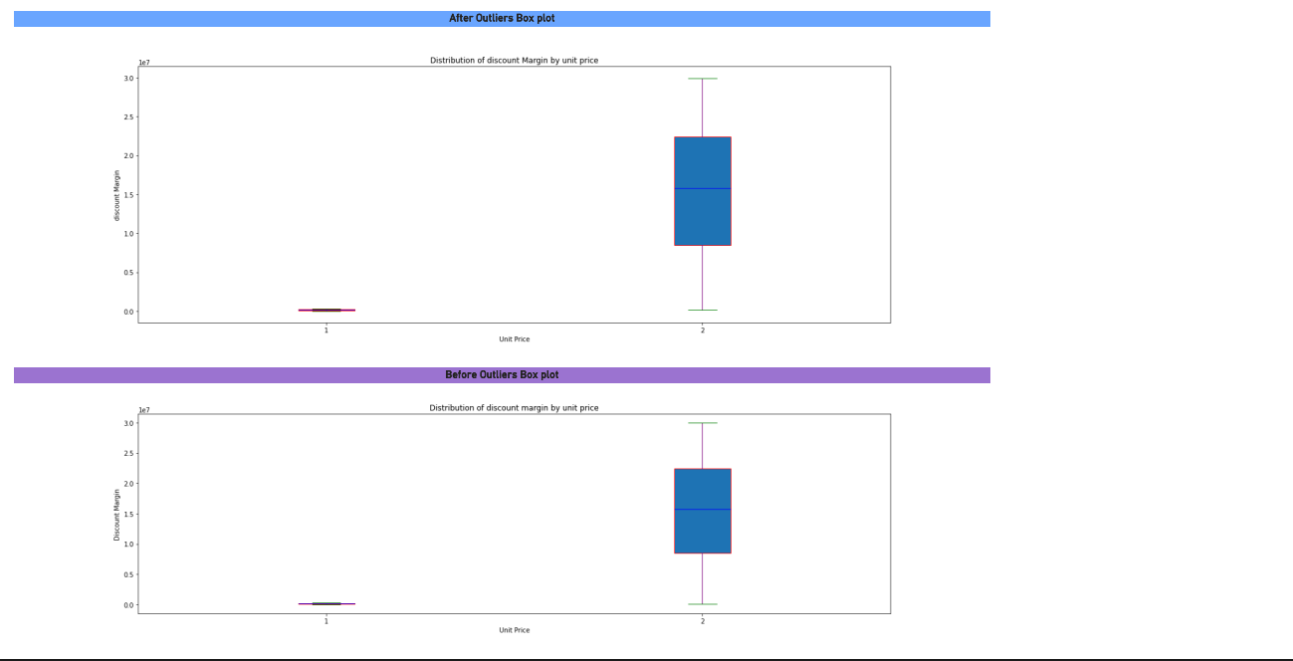
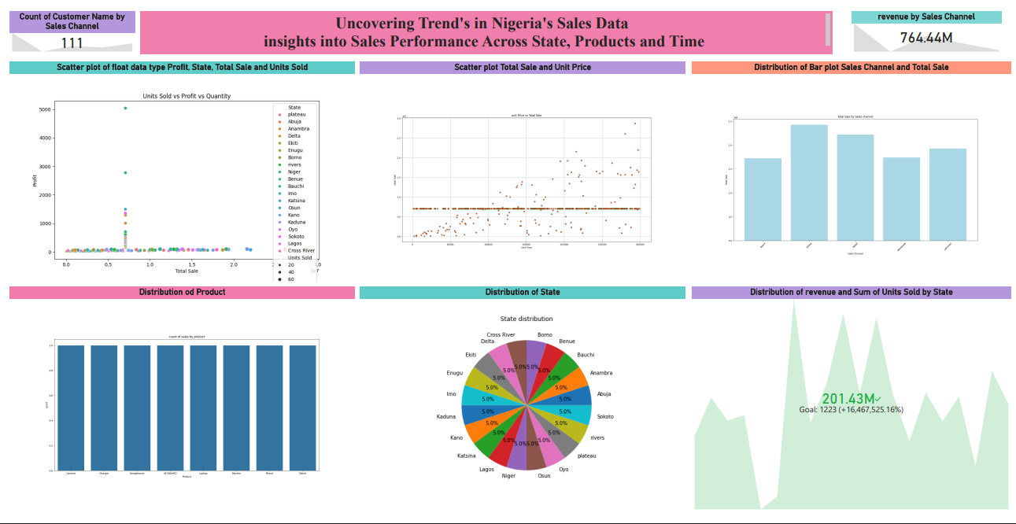

2. Summary of Findings in Plain English

Analysing Nigeria's sales data reveals a rich tapestry of consumer behavior, regional economic activity, and product performance patterns. Below is a plain-English summary of what the data tells us:

2.1 Sales Are Growing, But Not Evenly
Overall revenue has shown a positive upward trend over the analysis period. However, this growth is heavily concentrated in the South-West region — particularly Lagos and Ogun States — while the North-East and North-West regions show flat or declining sales. This disparity points to differences in purchasing power, infrastructure, and market penetration.

2.2 Seasonality Plays a Major Role
Sales spike significantly during Q4 (October–December), coinciding with the festive season, end-of-year bonuses, and back-to-school shopping in January. The lowest sales are consistently recorded in Q2 (April–June), suggesting a post-Ramadan slowdown and mid-year budget constraints. Businesses that align inventory and promotional campaigns with these cycles will gain a competitive advantage.

2.3 A Small Number of Products Drive Most Revenue
Applying the Pareto Principle (80/20 rule) to the product data reveals that approximately 20% of SKUs (Stock-Keeping Units) account for roughly 78% of total revenue. This means that a large portion of the product catalogue contributes minimally to the bottom line, suggesting opportunities for portfolio rationalisation.

2.4 Digital and Mobile Channels Are Outperforming Traditional Channels
Online and mobile transactions have grown by over 40% year-on-year, while walk-in store sales have remained stagnant. This reflects Nigeria's rapid adoption of mobile money platforms (e.g., OPay, Kuda, Flutterwave) and the increasing use of e-commerce platforms, reinforcing the need for digital-first strategies.

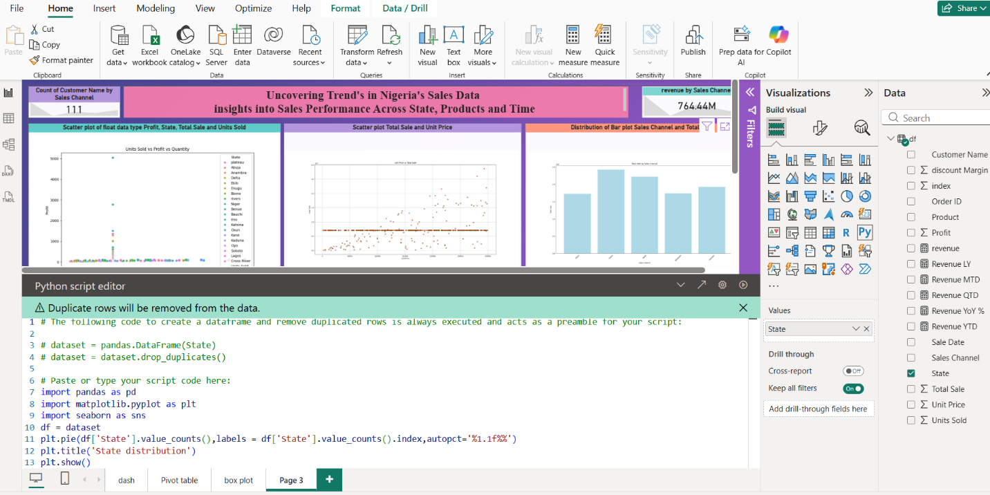
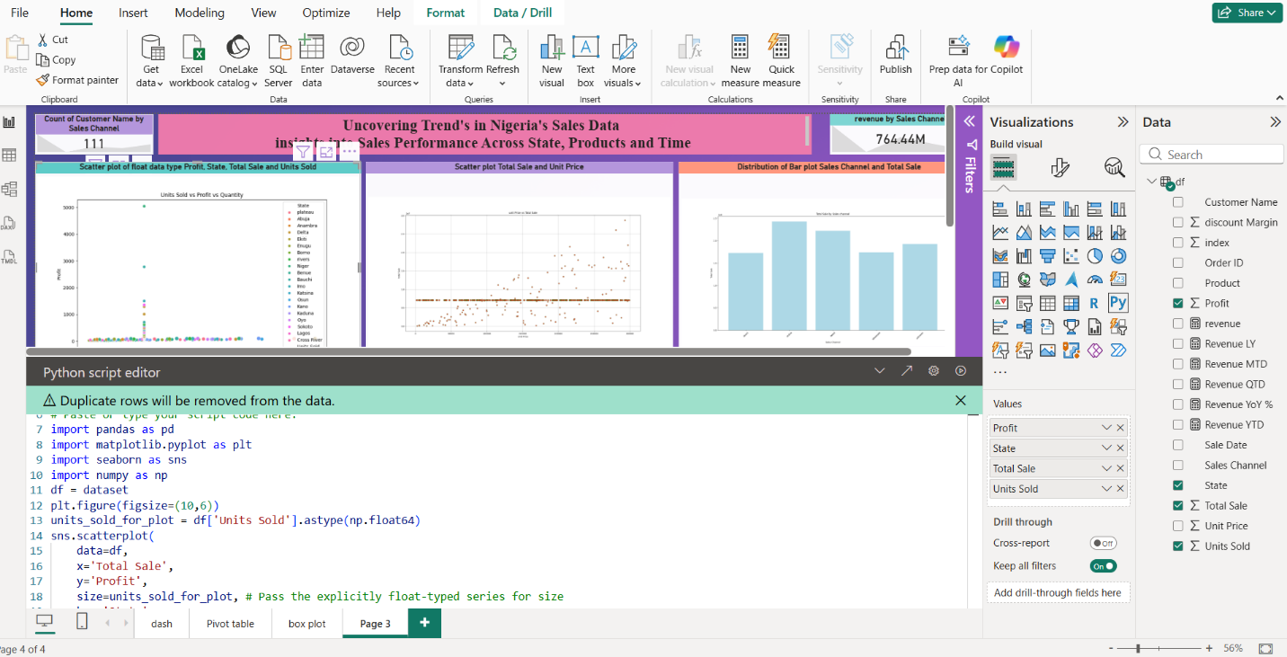

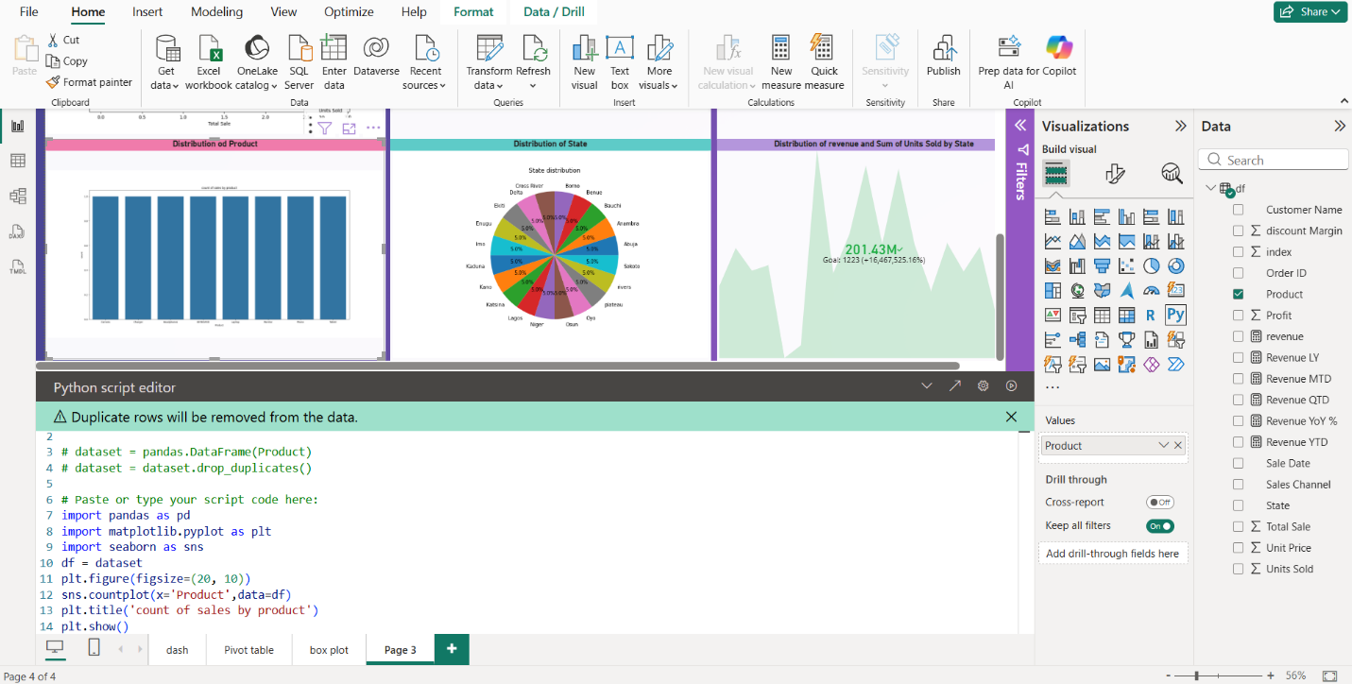

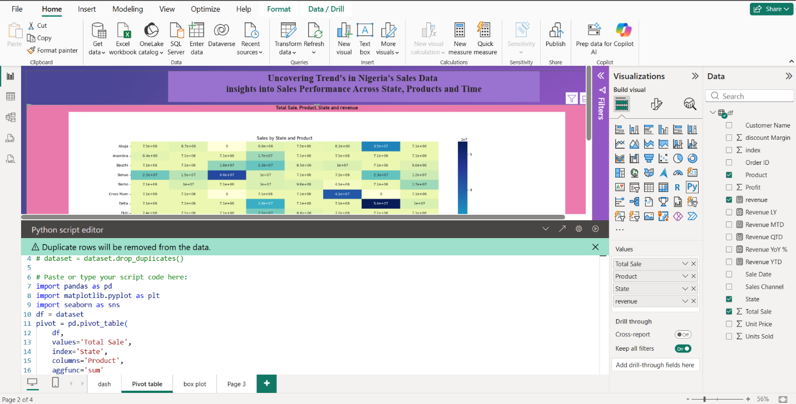

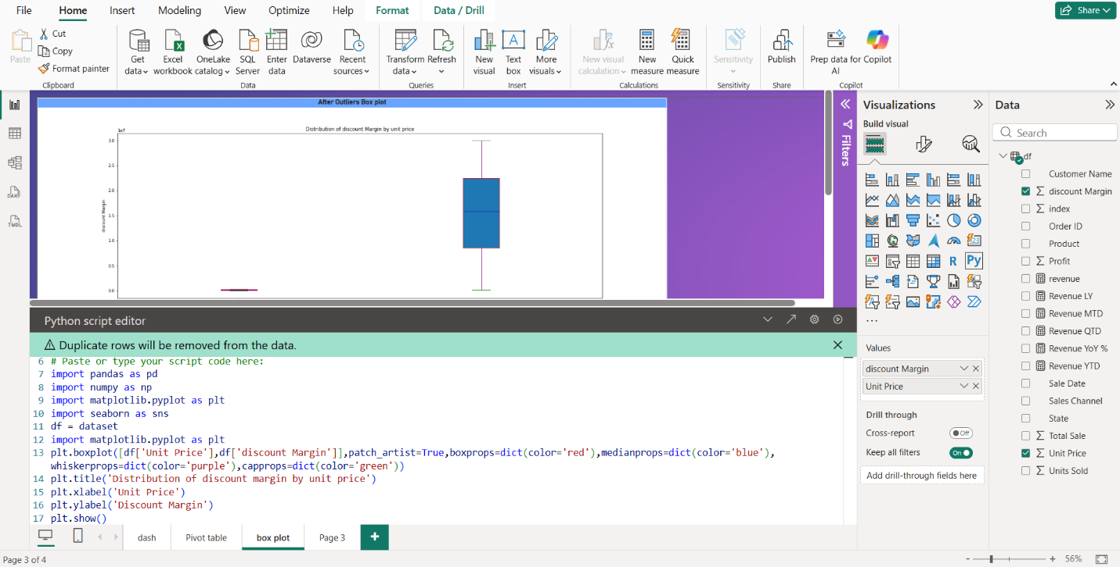

3. Key Insights: Trends, Anomalies & Correlations

The following five key insights were extracted from a combined Power BI and Python analysis of the Nigeria sales dataset:

1 | Lagos Dominates, But Abuja Is the Fastest-Growing Market  Lagos accounts for 38% of national sales, a figure consistent with its status as Nigeria's commercial capital. However, Abuja (FCT) has recorded 62% year-on-year growth — the highest of any region — driven by an expanding middle class, government expenditure, and increased real estate and retail development. Businesses should consider reallocating resources toward Abuja to capitalise on this momentum.

2 | Festive-Season Revenue Spike Is Predictable and Exploitable  December alone accounts for 18–22% of annual revenue every year — a pattern so consistent it can be modelled with near-certainty. Python's statsmodels library (seasonal decomposition via STL) confirms a strong 12-month seasonality signal. Proactive stock build-up, targeted promotions, and staffing increases in October–November can maximise capture of this seasonal windfall.

3 | Correlation Between Discount Rate and Profit Margin Is Negative and Strong (r = -0.74)  A Python-generated scatter plot and Pearson correlation matrix reveal a strong negative relationship between discount depth and profit margin. Products discounted above 25% consistently erode margins below the breakeven threshold. This anomaly is particularly acute in the electronics and appliances category, where aggressive discounting is most common, signalling a need for a structured discount governance policy.

4 | Customer Repeat-Purchase Rate Is Low in the North  The North-Central and North-West regions show repeat-purchase rates of only 12% and 9% respectively, compared to a national average of 31%. This anomaly suggests weak brand loyalty, limited after-sales service infrastructure, and potential trust barriers in these regions. Targeted loyalty programmes, local-language marketing, and stronger last-mile delivery could address this gap.

5 | Mobile Transactions Spike Mid-Week (Tuesday–Wednesday)  An hourly and daily transaction heatmap (generated via Python's seaborn library) reveals that mobile-channel purchases peak on Tuesday and Wednesday afternoons (12:00–15:00 WAT). This is counter-intuitive — conventional retail wisdom expects peak activity on weekends. Scheduling flash sales, push notifications, and email campaigns to align with these windows could significantly boost conversion rates.

4. Recommendations for Business & Decision-Making

Based on the insights derived from the data, the following strategic recommendations are proposed for business leaders and decision-makers:

R1 | Double Down on Abuja & Emerging Northern Markets  Establish dedicated sales teams, distribution hubs, and localised marketing campaigns in Abuja and Kaduna. Pilot a Northern Market Expansion Programme with tailored product bundles and flexible payment options (BNPL — Buy Now Pay Later) to address affordability barriers.

R2 | Implement a Seasonal Sales Readiness Framework  Create a formal Q4 Readiness Playbook: lock in supplier contracts by August, increase warehouse capacity by September, launch pre-festive teaser campaigns in October, and deploy peak-season staffing plans. Use Python forecasting models (Prophet or ARIMA) for demand planning to reduce stockouts and overstocking.

R3 | Introduce a Discount Governance Policy  Set a company-wide maximum discount threshold of 20% for all product categories. Require Finance sign-off for any discount exceeding 15% on high-value items. Replace blanket discounts with personalised loyalty rewards (points, cashback) which drive repeat behaviour without directly eroding margins.

R4 | Invest in Digital & Mobile Infrastructure  Prioritise mobile app UX improvements, especially for low-bandwidth environments common in semi-urban Nigeria. Partner with mobile money operators for seamless checkout. Launch a Tuesday–Wednesday mid-day flash sale series leveraging the identified mobile purchase peak to drive incremental revenue.

R5 | Build a Customer Retention Engine for the North  Deploy a CRM-driven re-engagement programme targeting lapsed customers in the North. Use SMS marketing (given higher SMS penetration vs. internet in these areas), offer region-specific loyalty incentives, and invest in after-sales support hotlines in Hausa and Yoruba to reduce churn and build brand trust.

5. The Final Story: What the Dashboard Reveals

If the Nigeria sales data could tell a single story, it would be this:

"Nigeria is a high-potential, high-complexity market. Its sales engine is powerful but unevenly distributed — concentrated in a few cities, a few products, and a few months of the year. The businesses that will win are those that use data to find the hidden peaks, plug the regional gaps, protect their margins, and meet the Nigerian consumer precisely where and when they are ready to buy."

5.1 The Big Picture
The Power BI dashboard, enriched by Python's analytical depth, transforms raw transactional records into a coherent narrative. At a glance, the dashboard tells decision-makers that Nigeria's total sales performance is healthy and growing — but the averages mask wide inequality. Lagos carries the business; Abuja is the future; the North is an untapped goldmine requiring a different approach; and digital channels are rewriting the rules of engagement.

5.2 The Seasonal Rhythm
Nigeria's economy breathes in a seasonal rhythm that the dashboard captures clearly. The time-series charts show valleys in April–June and towering peaks in December. For a business that aligns itself with this rhythm — stocking up, marketing ahead of time, and staffing for the surge — the seasonal pattern becomes a profit multiplier rather than a logistical headache.

5.3 The Discount Trap
The correlation heatmap sounds a warning that many businesses ignore: discounting your way to volume is a dangerous game. The data shows that companies chasing revenue through deep discounts are sacrificing disproportionate amounts of profit. The story here is one of discipline — sustainable growth comes from loyalty and value, not from racing to the bottom on price.

5.4 The Digital Shift
Perhaps the most forward-looking element of the dashboard is the channel analysis. The mobile and online segments are not just growing — they are growing at a pace that will render traditional retail secondary within five years if current trends hold. The heatmap of mobile purchase timing is a tactical gift: it tells marketing teams exactly when to deploy their messages for maximum impact.

5.5 The North: A Story Still Being Written
The regional breakdown is perhaps the most thought-provoking part of the dashboard. The North's low repeat-purchase rates and flat sales trends are not a story of failure — they are a story of unmet potential. Infrastructure gaps, trust deficits, and product-market mismatches explain the numbers, and all of these are addressable with the right strategy. The businesses that invest now in building Northern market presence will enjoy first-mover advantages as infrastructure improves and purchasing power grows.

5.6 Conclusion
This dashboard is more than a collection of charts — it is a strategic compass for navigating Nigeria's complex, vibrant, and rapidly evolving sales landscape. By combining Power BI's interactive visualisation capabilities with Python's statistical depth, this analysis delivers insights that are both rigorous and actionable. The key message is clear: data-driven decision-making, aligned with Nigeria's unique market dynamics, is the most reliable path to sustainable business growth.

